**RESTful API for a holiday booking system using JAX-RS in Java**

**UML Class Diagram:**

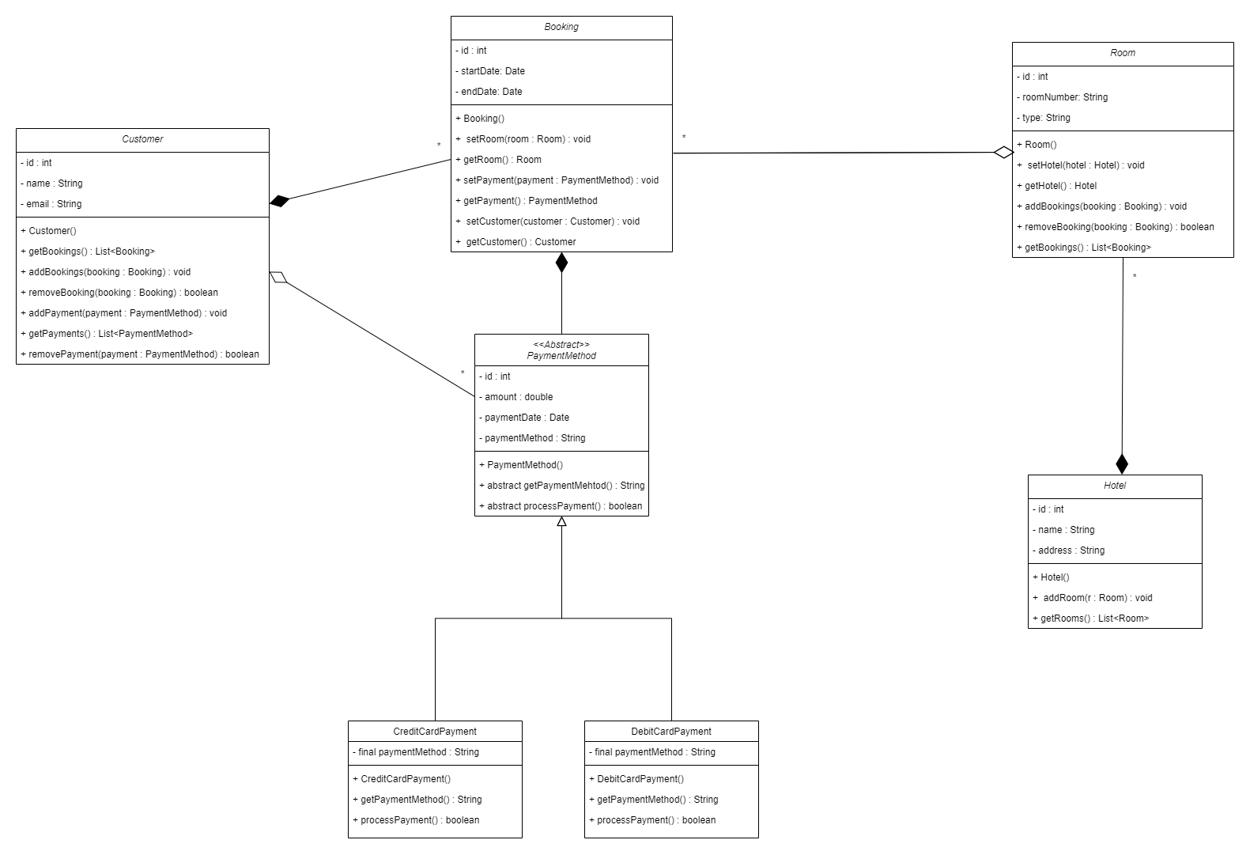

**Test Cases:**

Endpoint : <http://localhost:8080/holidayBookingSystem/api/bookings>

Method : GET

Response :

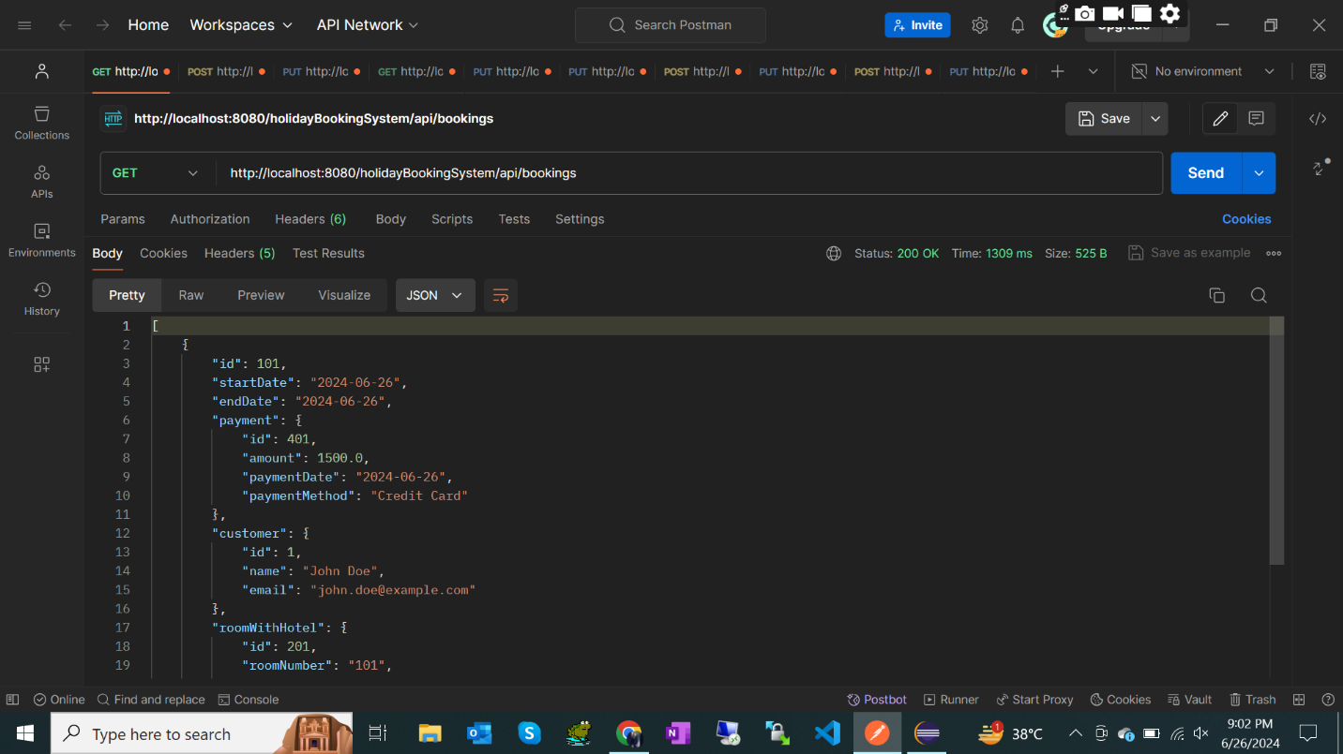

Endpoint : <http://localhost:8080/holidayBookingSystem/api/bookings/101>

Method : GET with Path ID

Response :

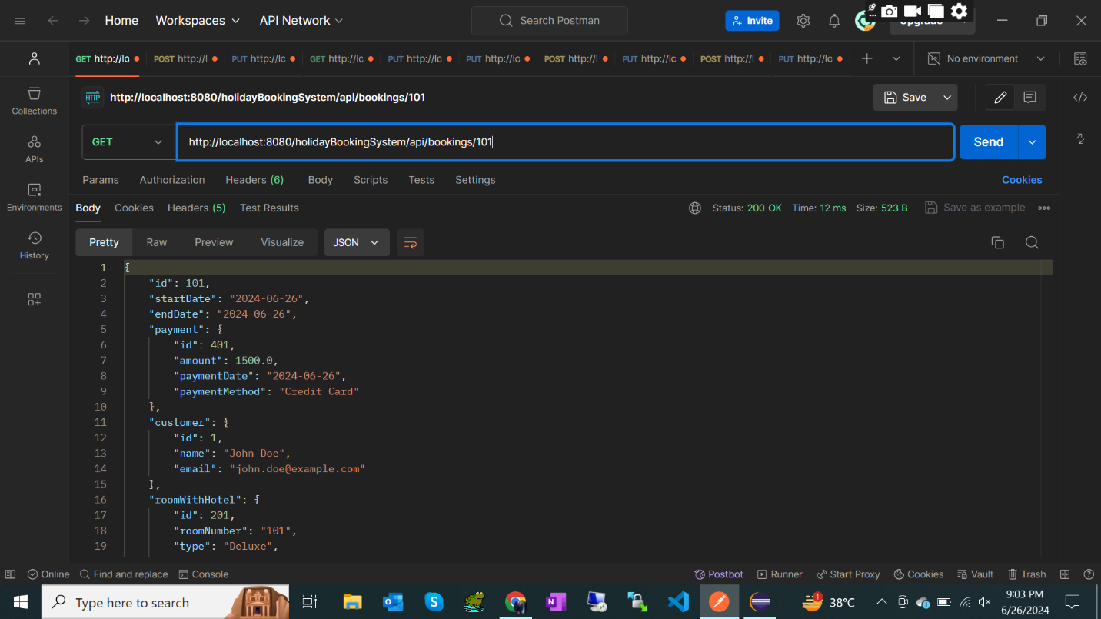

Endpoint : <http://localhost:8080/holidayBookingSystem/api/bookings/101>

Method : DELETE

Response :

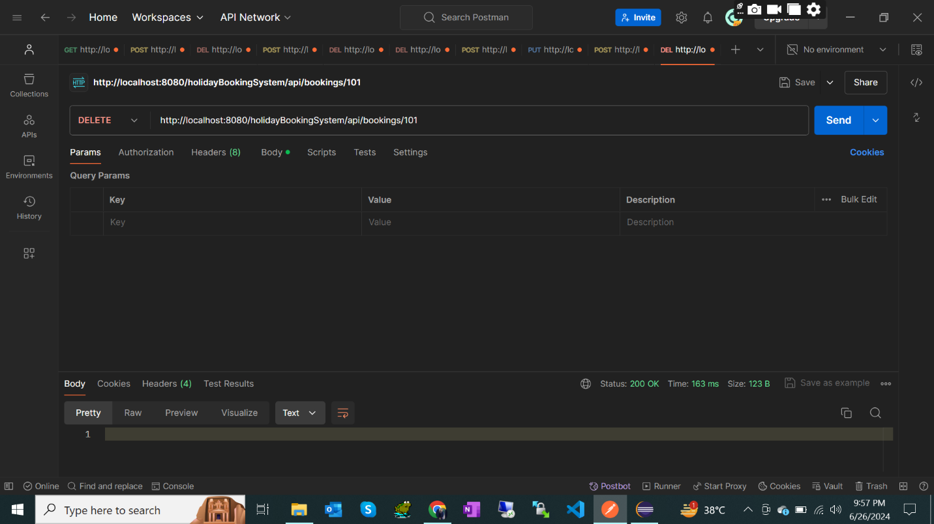

Endpoint : <http://localhost:8080/holidayBookingSystem/api/bookings/rooms/201>

Method : POST

Response :

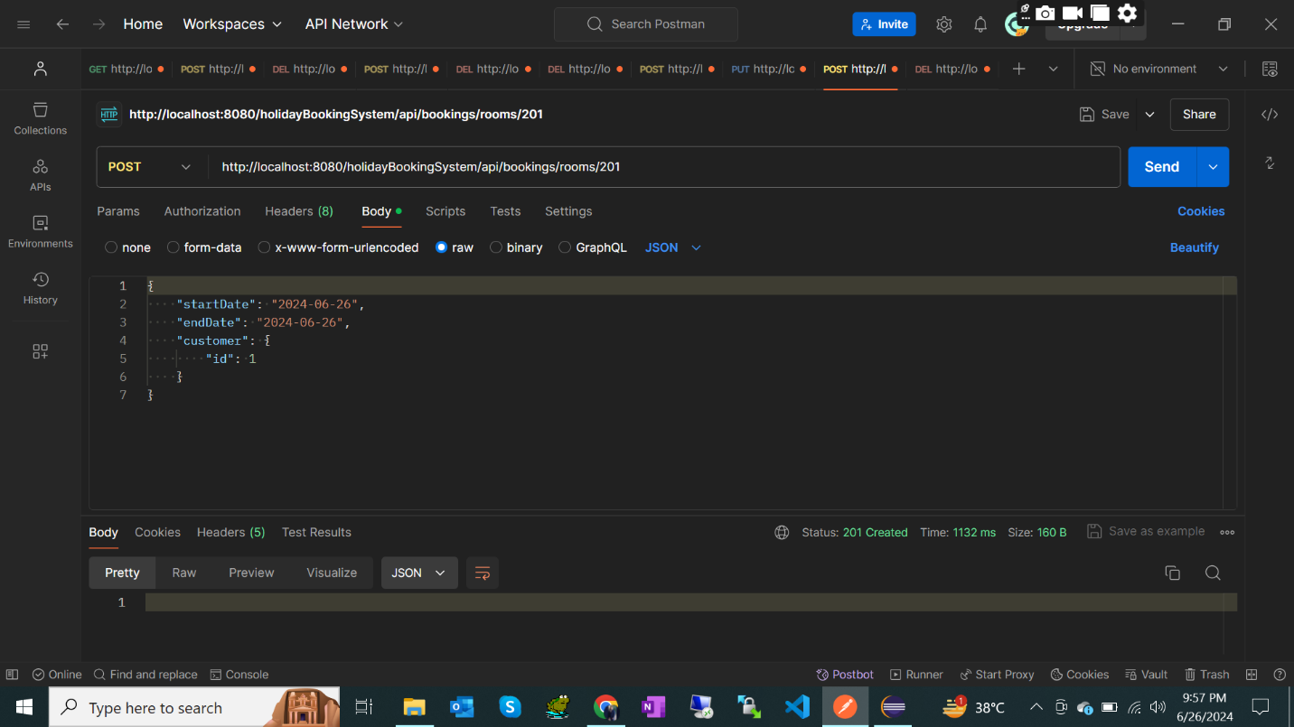

Endpoint : <http://localhost:8080/holidayBookingSystem/api/bookings/102>

Method : PUT

Response :

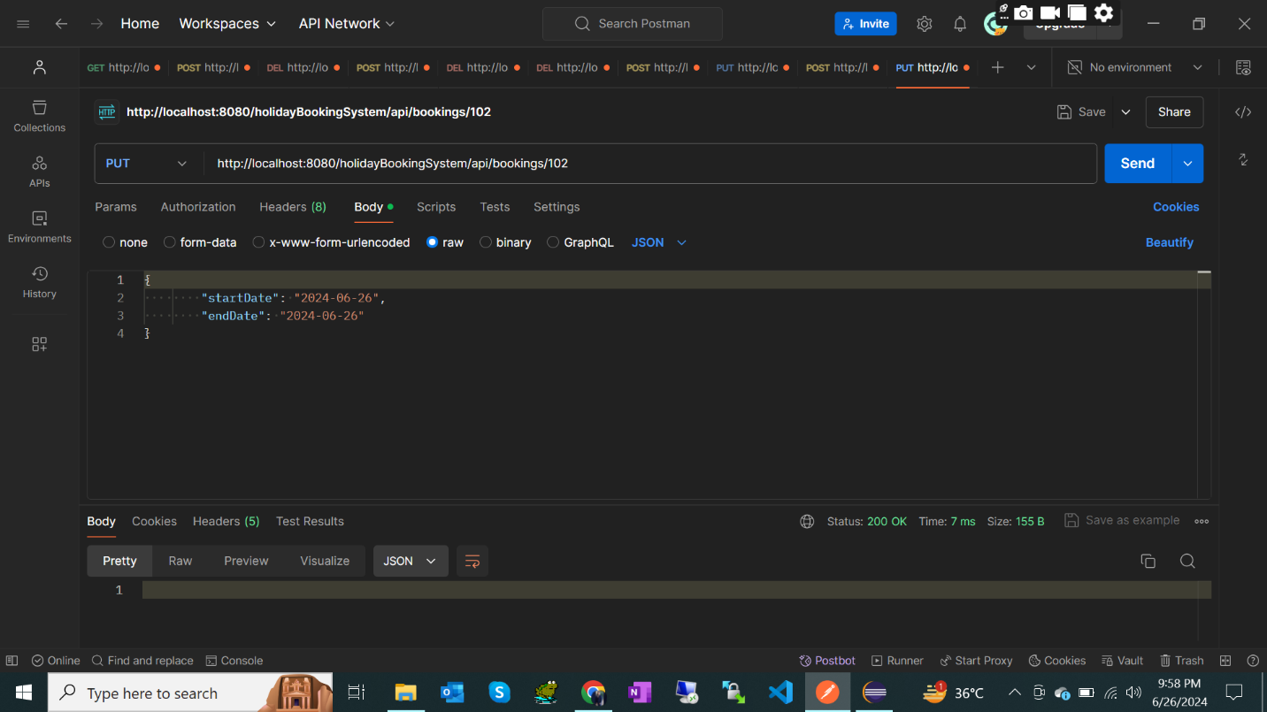

Endpoint : <http://localhost:8080/holidayBookingSystem/api/customers>

Method : GET

Response :

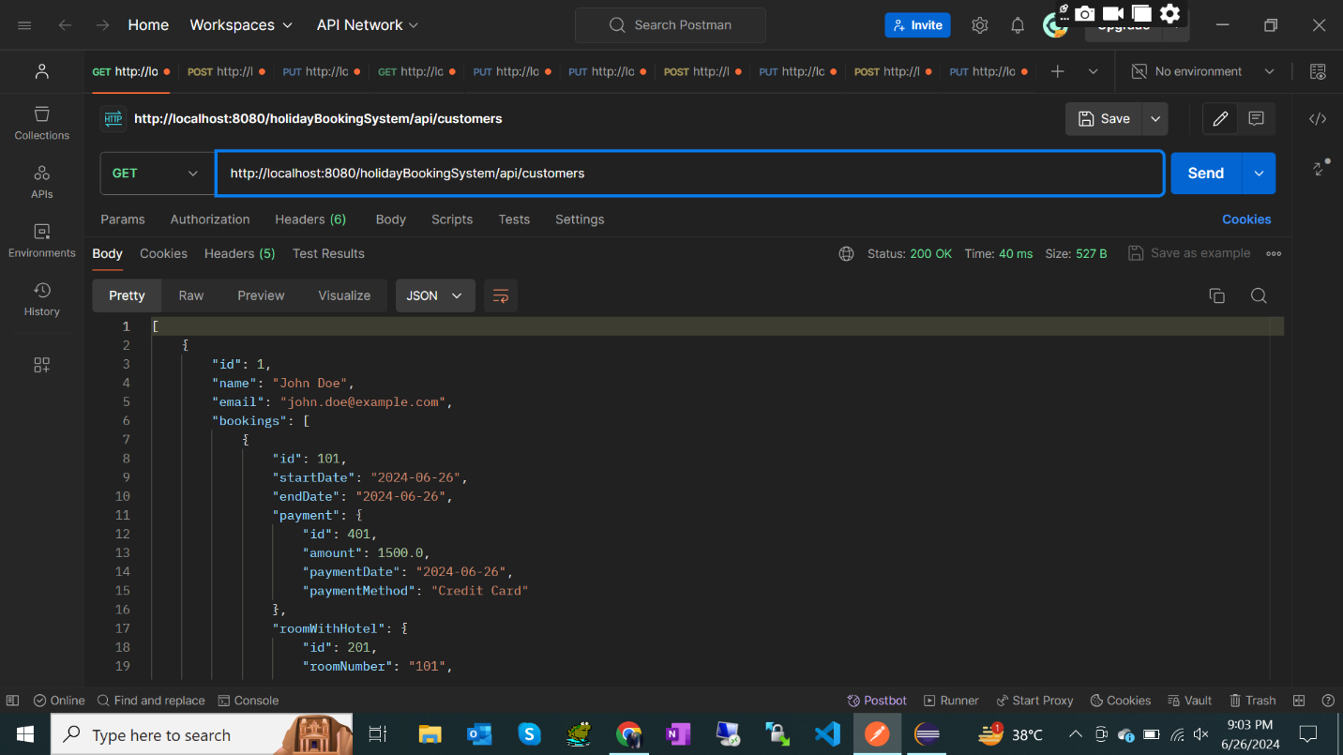

Endpoint : <http://localhost:8080/holidayBookingSystem/api/customers/1>

Method : GET with Path ID

Response :

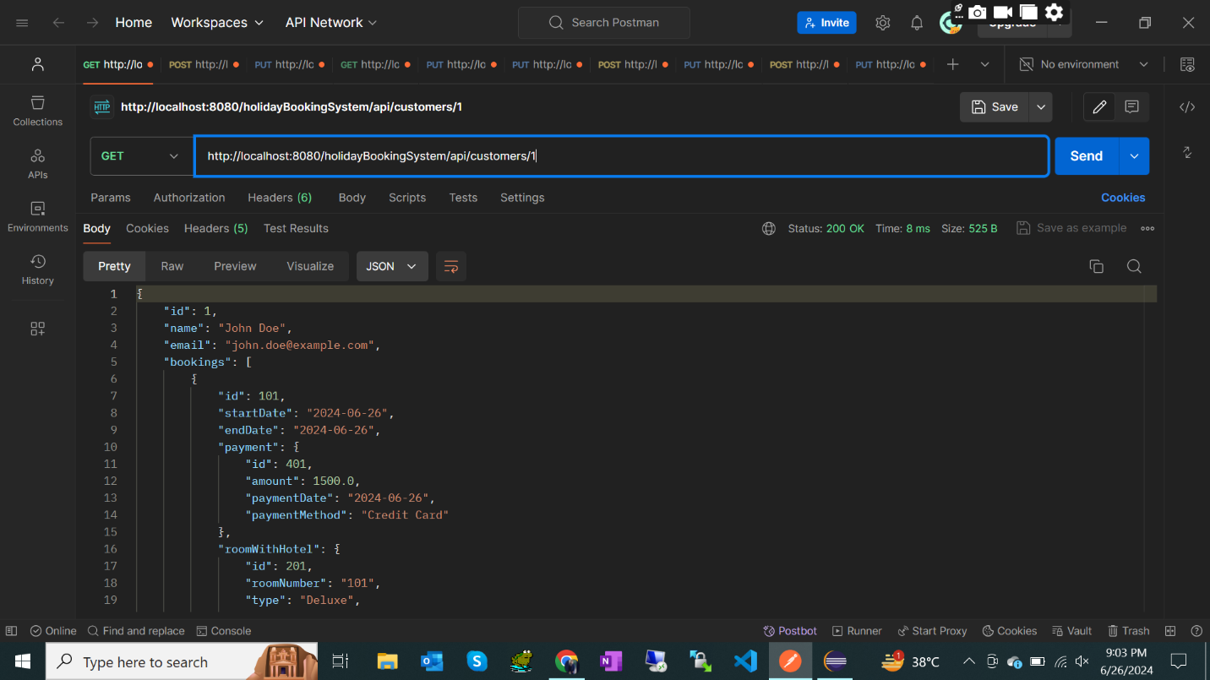

Endpoint : <http://localhost:8080/holidayBookingSystem/api/customers>

Method : POST

Response :

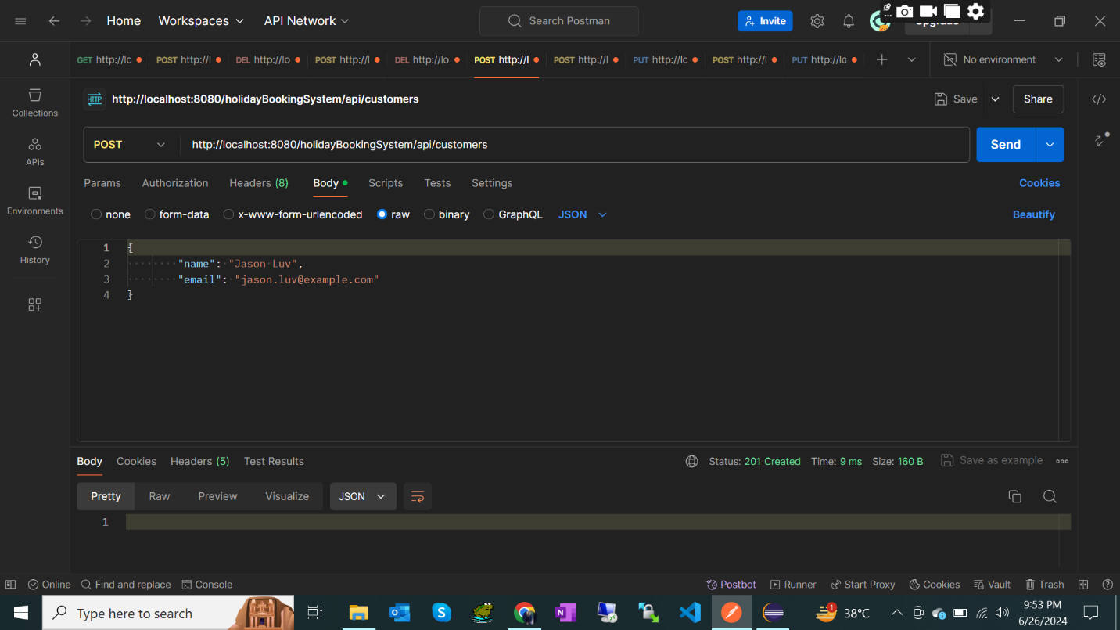

Endpoint : [http://localhost:8080/holidayBookingSystem/api/customers/2](http://localhost:8080/holidayBookingSystem/api/customers/21)

Method : PUT

Response :

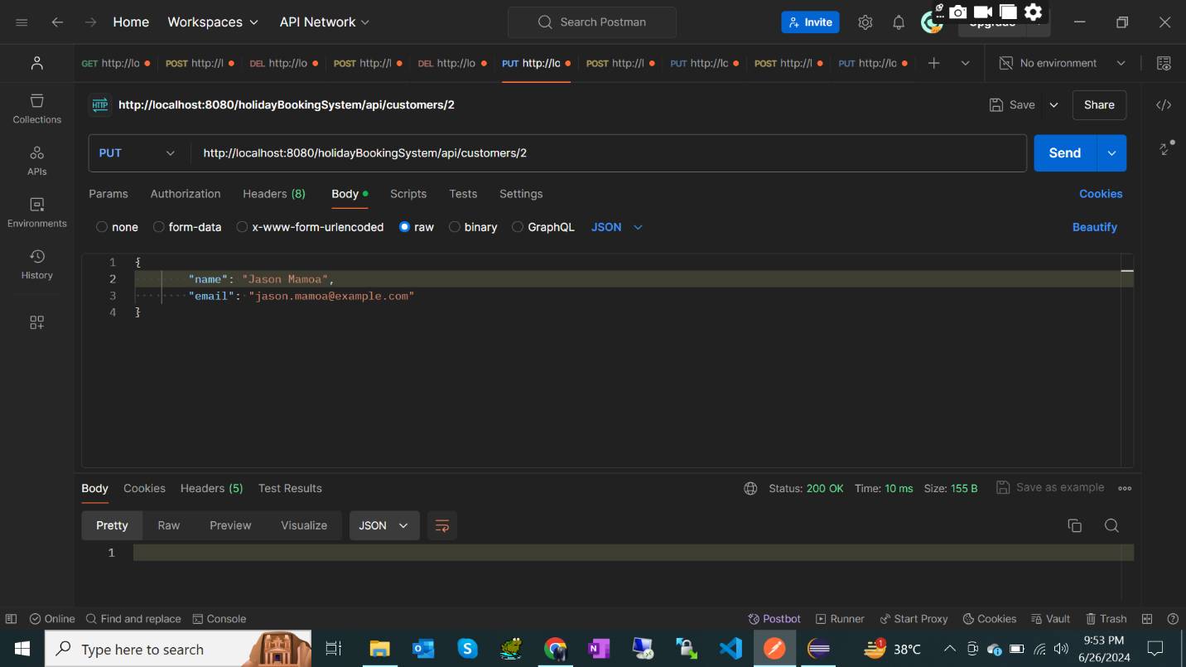

Endpoint : [http://localhost:8080/holidayBookingSystem/api/customers/2](http://localhost:8080/holidayBookingSystem/api/customers/21)

Method : DELETE

Response :

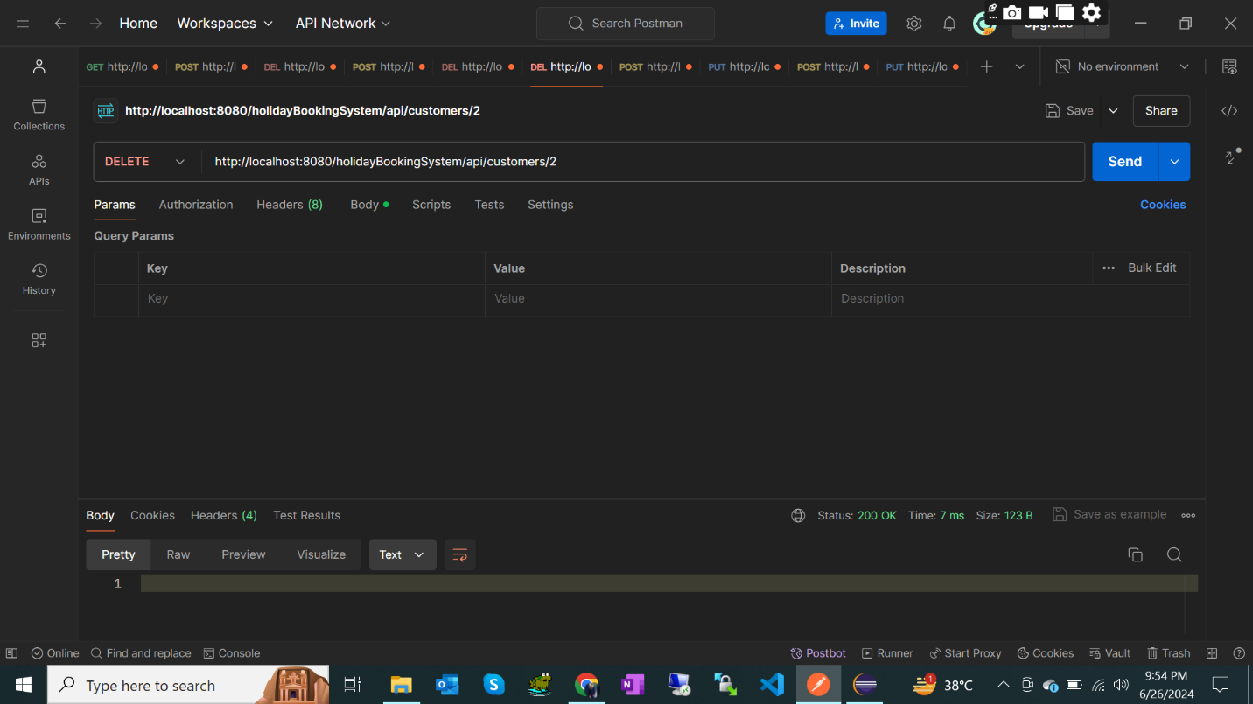

Endpoint : <http://localhost:8080/holidayBookingSystem/api/payments>

Method : GET

Response :

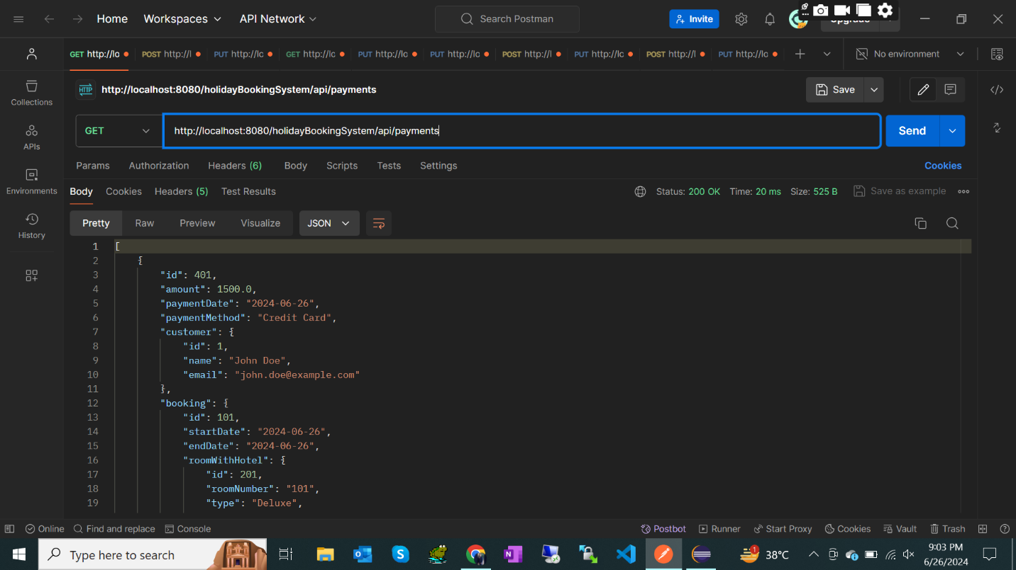

Endpoint : <http://localhost:8080/holidayBookingSystem/api/payments>

Method : POST

Response :

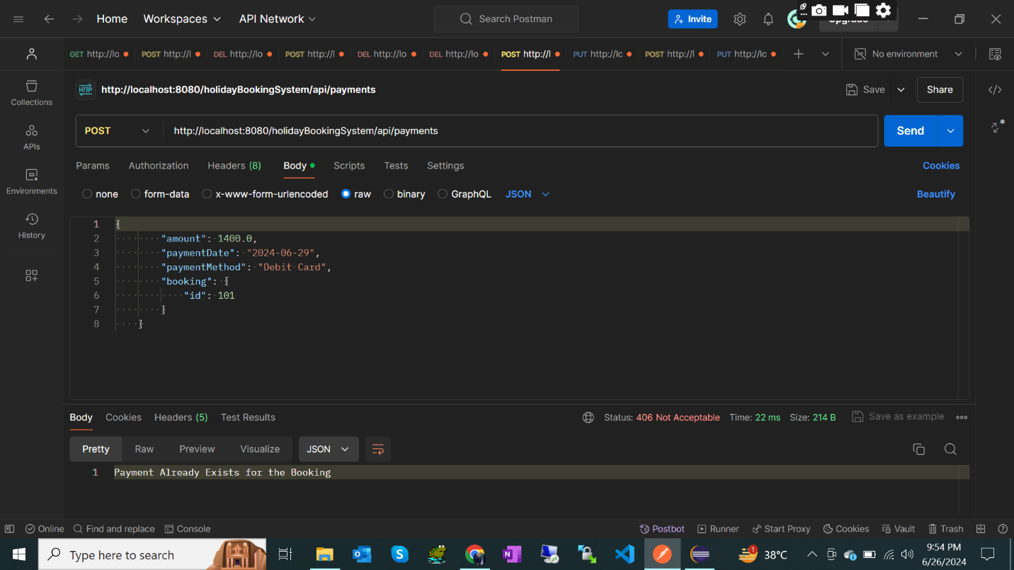

Endpoint : <http://localhost:8080/holidayBookingSystem/api/payments/401>

Method : GET with Path ID

Response :

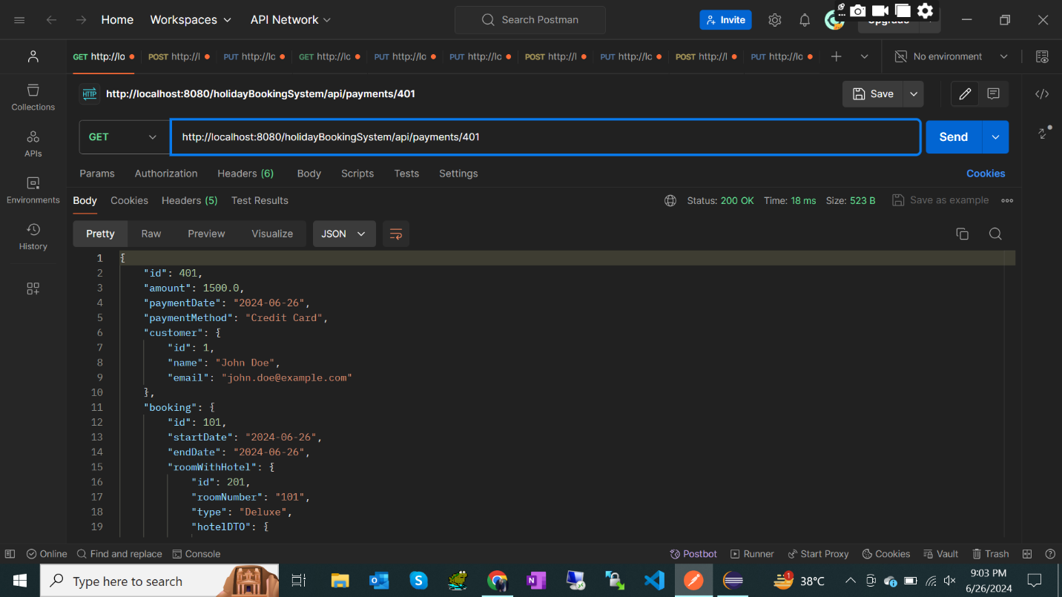

Endpoint : <http://localhost:8080/holidayBookingSystem/api/payments/402>

Method : PUT

Response :

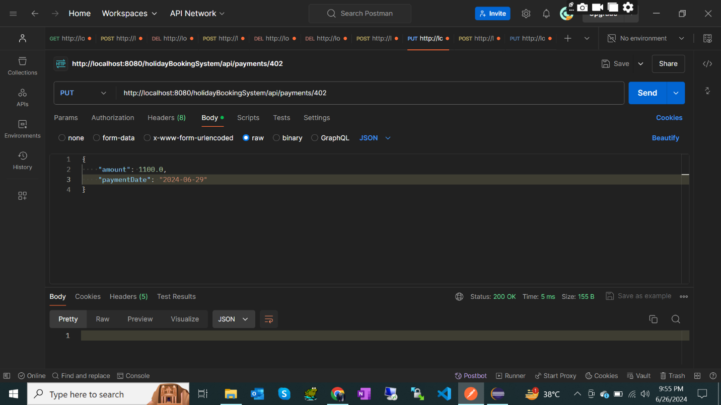

Endpoint : <http://localhost:8080/holidayBookingSystem/api/payments/401>

Method : DELETE

Response :

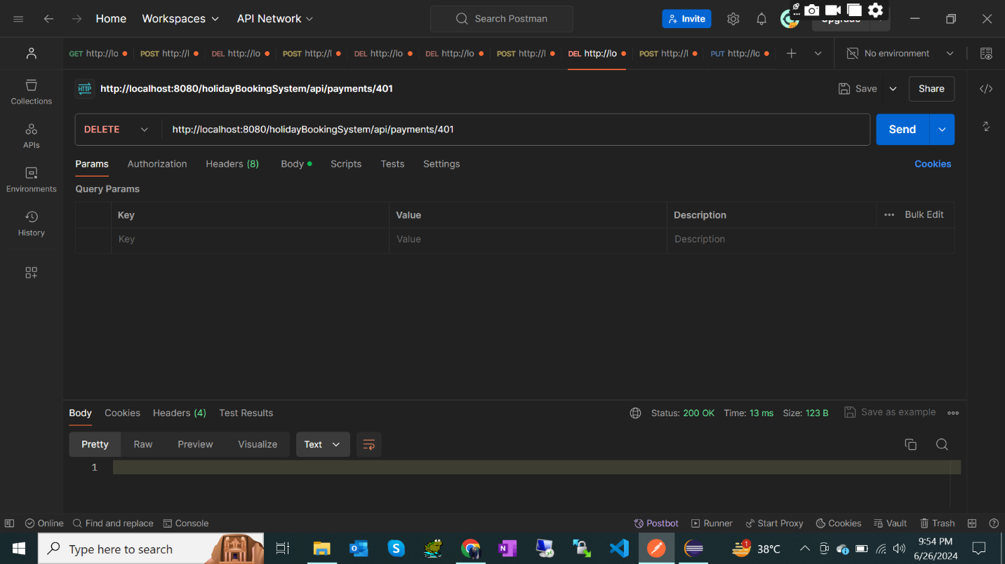

Endpoint : <http://localhost:8080/holidayBookingSystem/api/hotels>

Method : GET

Response :

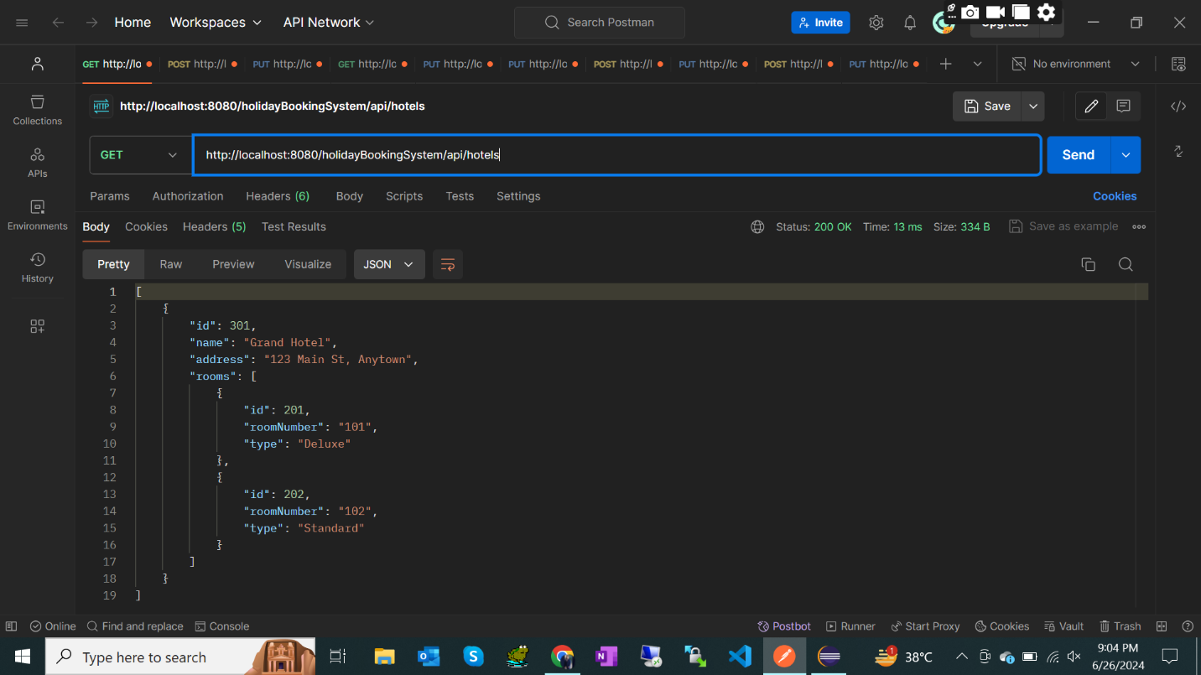

Endpoint : <http://localhost:8080/holidayBookingSystem/api/hotels/301>

Method : GET with Path ID

Response :

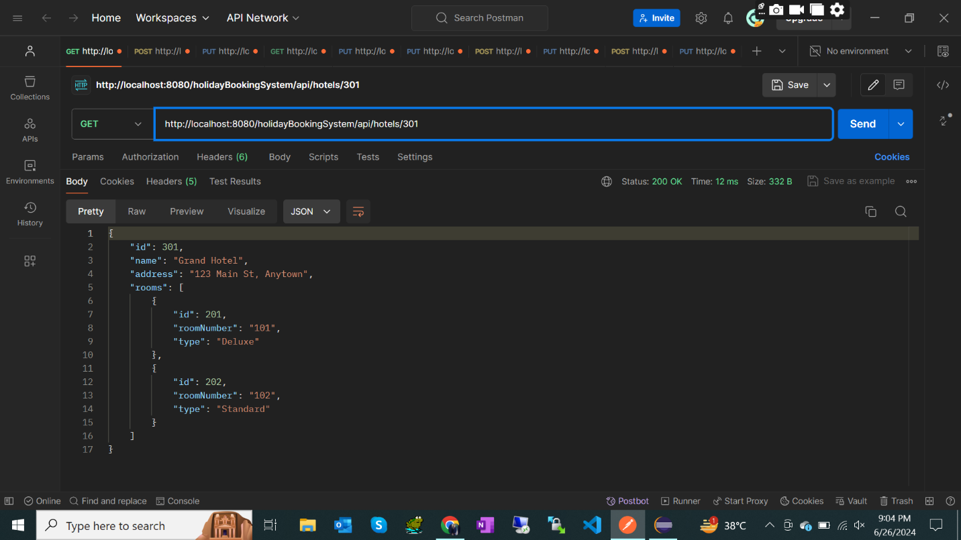

Endpoint : <http://localhost:8080/holidayBookingSystem/api/hotels>

Method : POST

Response :

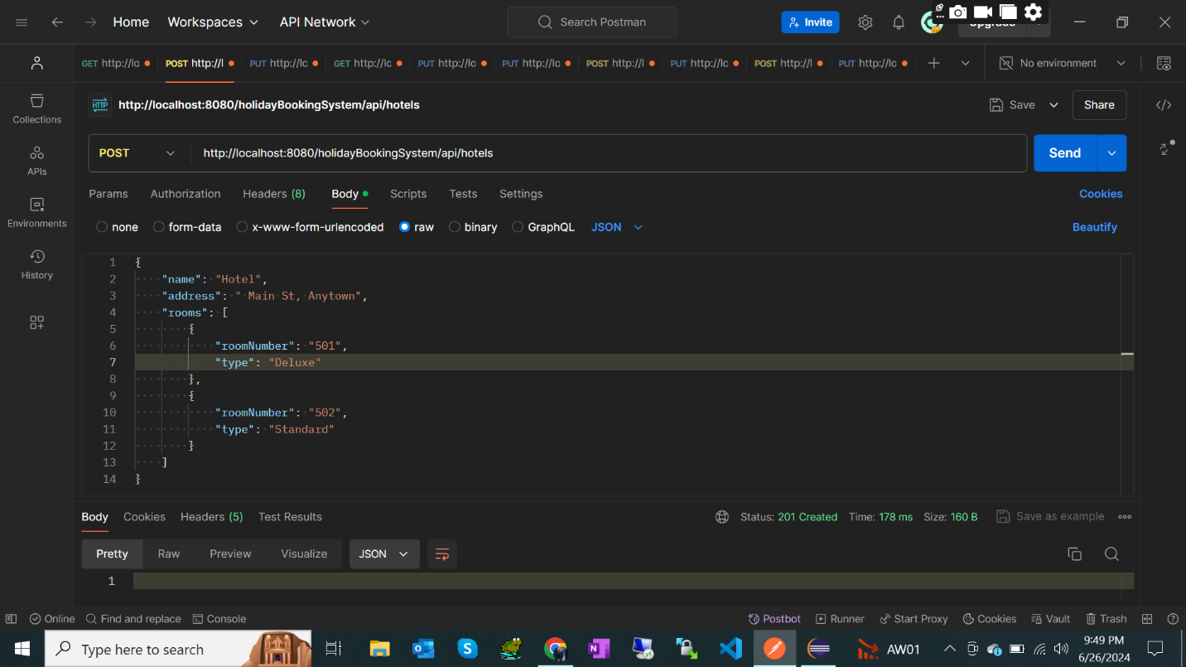

Endpoint : <http://localhost:8080/holidayBookingSystem/api/hotels/302>

Method : PUT

Response :

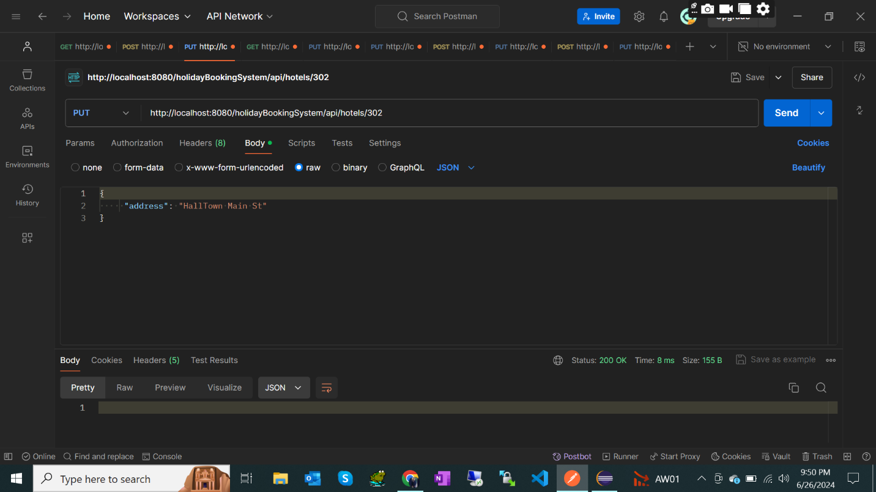

Endpoint : <http://localhost:8080/holidayBookingSystem/api/hotels/302>

Method : DELETE

Response :

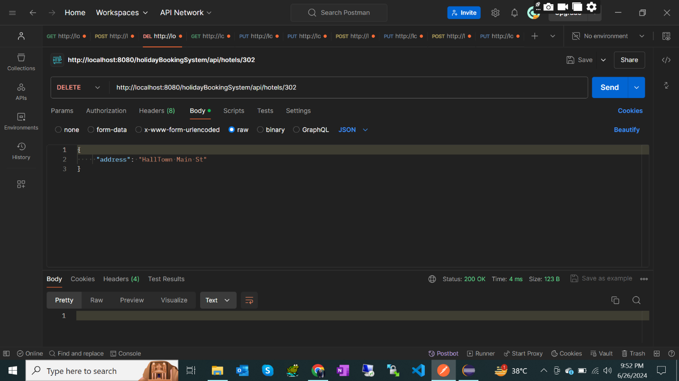

Endpoint : <http://localhost:8080/holidayBookingSystem/api/rooms>

Method : GET

Response :

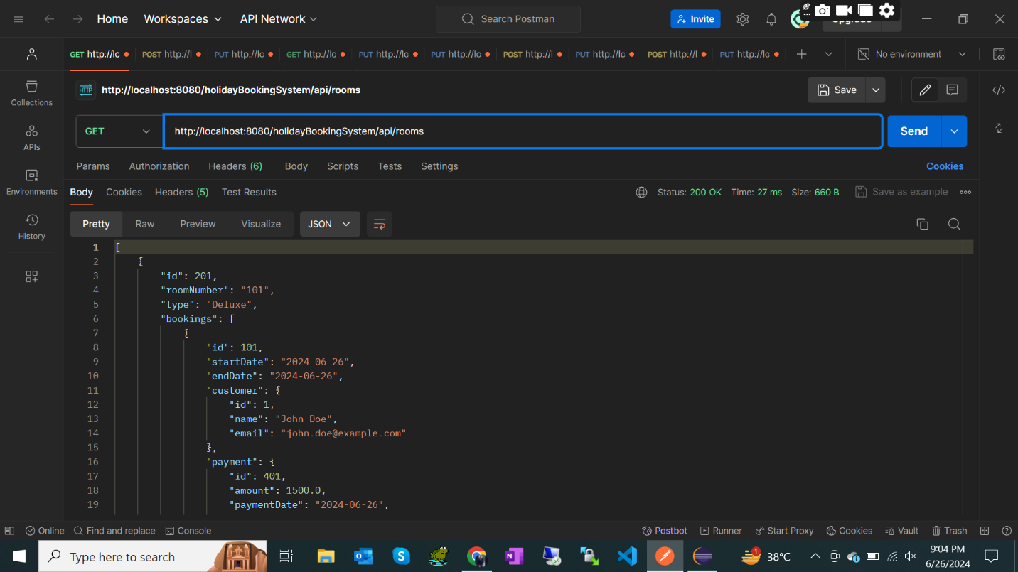

Endpoint : <http://localhost:8080/holidayBookingSystem/api/rooms/201>

Method : GET with Path ID

Response :

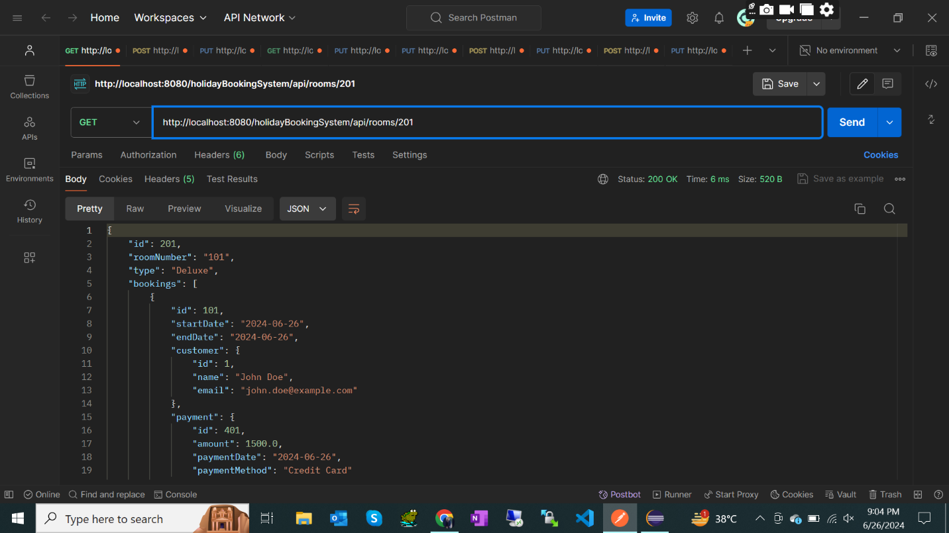

Endpoint : <http://localhost:8080/holidayBookingSystem/api/rooms>

Method : POST

Response :

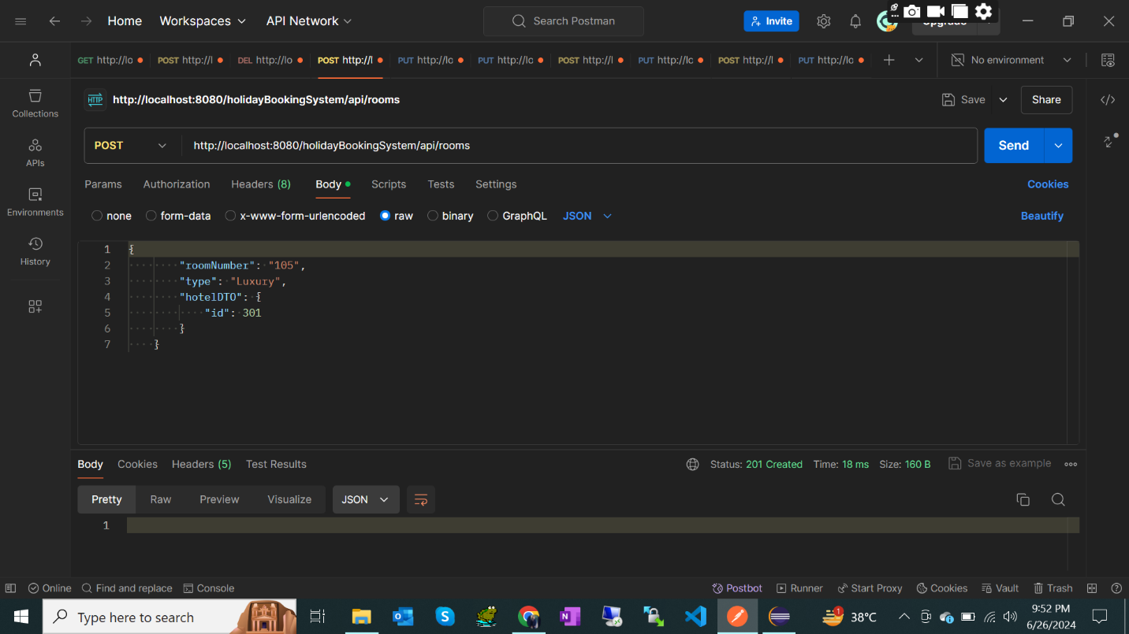

Endpoint : <http://localhost:8080/holidayBookingSystem/api/rooms/201>

Method : PUT

Response :

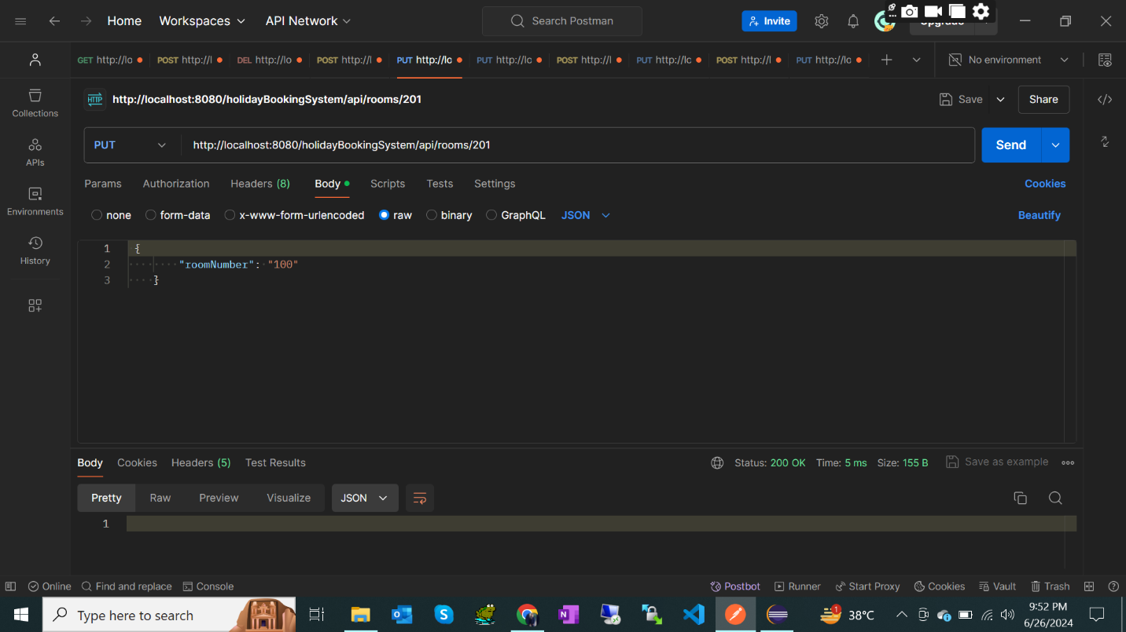

Endpoint : <http://localhost:8080/holidayBookingSystem/api/rooms/201>

Method : DELETE

Response :

